# **Founder Bios**

**Jason Citron, CEO & Co-Founder** 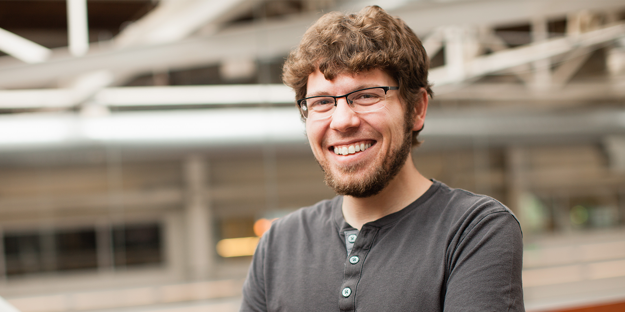

Jason Citron is the co-founder and CEO of Discord, a voice, video, and text service used by over 100 million people around the world. He currently oversees global strategy and product.

Since launching in 2015, under Jason’s leadership, Discord has become the best place for communities and friends to talk and hang out. Headquartered in San Francisco, the company has grown to over 250 employees globally.

Prior to co-founding Discord, Jason founded and served as CEO of OpenFeint, the biggest social mobile gaming platform, which sold to GREE in 2011 for $104 million.

Jason began his career in game programming, before pursuing his own entrepreneurial ventures in 2008. Both of Jason’s companies began as game studios on a mission to modernize the way people play games inspired by the memories and friendships he created from staying up all night playing Magic The Gathering, launching too many Blue Shells in Mario Kart, and playing just one more match of Starcraft.

Originally from Long Island, NY, he currently resides in the Bay Area with his wife and son. He sits on the Bay Area Leadership Board of the [Seneca Family of Agencies](https://www.senecafoa.org/leadership) and is a graduate of Full Sail University.

**Stanislav Vishnevskiy, Chief Technology Officer & Co-Founder**

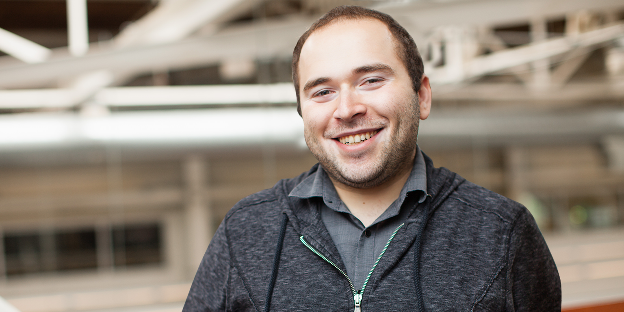

Stan Vishnevskiyis the co-founder and Chief Technology Officer of Discord, a voice, video, and text service used by over 100 million people around the world. He created and designed the service with CEO Jason Citron and continues to lead the company’s global product and engineering teams.

In 2013, Stan began working for Hammer & Chisel and in December 2014, he pitched the idea of Discord to Jason, after which the two began working on the project. In early 2015, the company officially shifted from a tablet-only game studio to a messaging service.

Even before Discord, Stan has had a long history in the gaming community. He previously led the highest-ranking Final Fantasy XI team in the world, and his love of online games helped him to create Guildwork - a social network and web hosting service for those playing massive multiplayer role-playing games. His personal and professional experience with coordinating a team online was the inspiration for building Discord to make it easier for people to talk before, during, and after playing games online.

Earlier in his career, Stan was a software engineer at GREE International and has also worked at Kabam, a mobile game studio. Originally from Ukraine, he spent most of his life in Los Angeles and currently resides in the Bay Area.